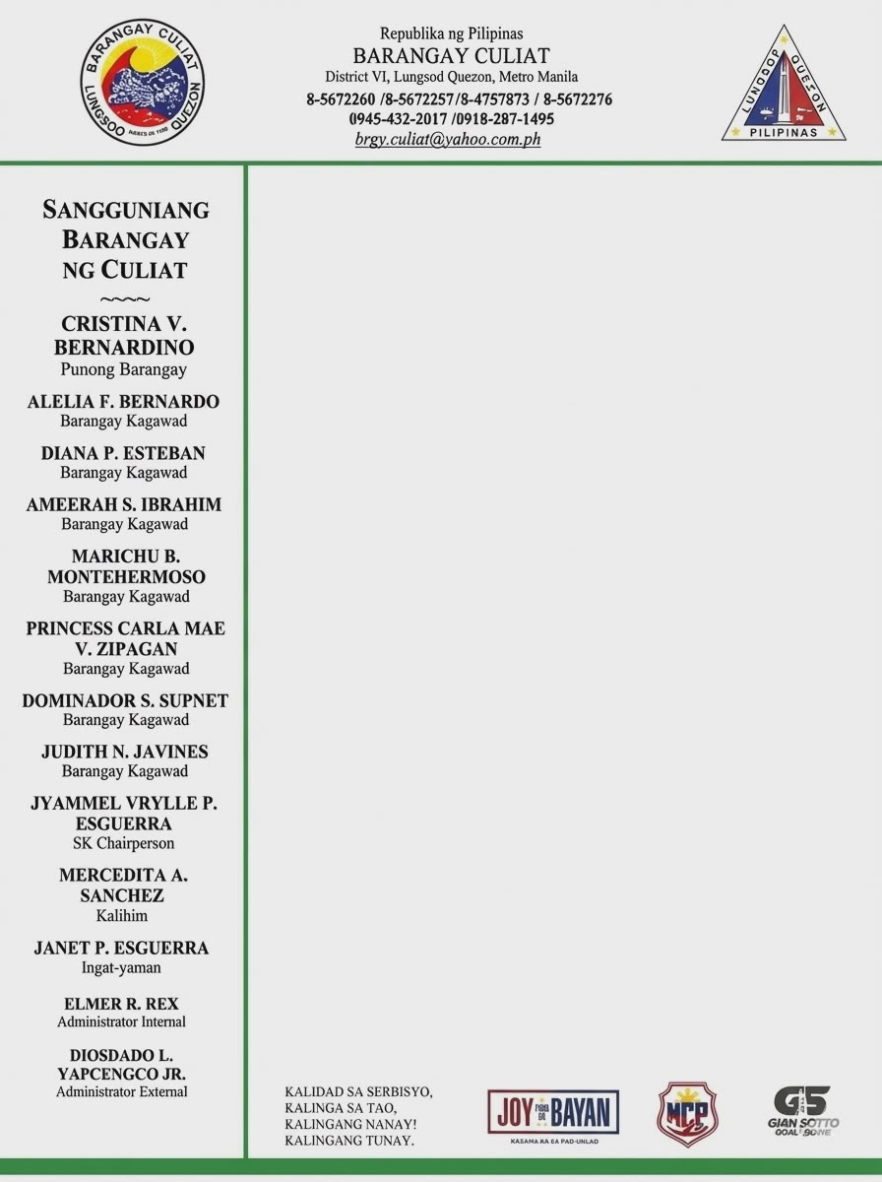

CERTIFICATION

TO WHOM IT MAY CONCERN:
This is certify that {salutation}{full_name}, with details stated below, of legal age, with postal address at {full_address}, Brgy. Culiat QC, whose specimen signature appears below, is a resident of this barangay since he/she arrived in the Philippines.
ACR No. : {acr_number}
Valid Until : {acr_valid_until} Passport No. : {passport_number} Nationality : {nationality}
This further certifies that the above-mentioned person is actually rendering missionary service in the community.
This certification is issued upon the request of {salutation}{full_name} as one of the requirements to renew his/her {purpose_of_request} from the Bureau of Immigration and for whatever legal purpose it may best serve.
Issued this {issue_date} in Barangay Culiat, District VI, Quezon City.

